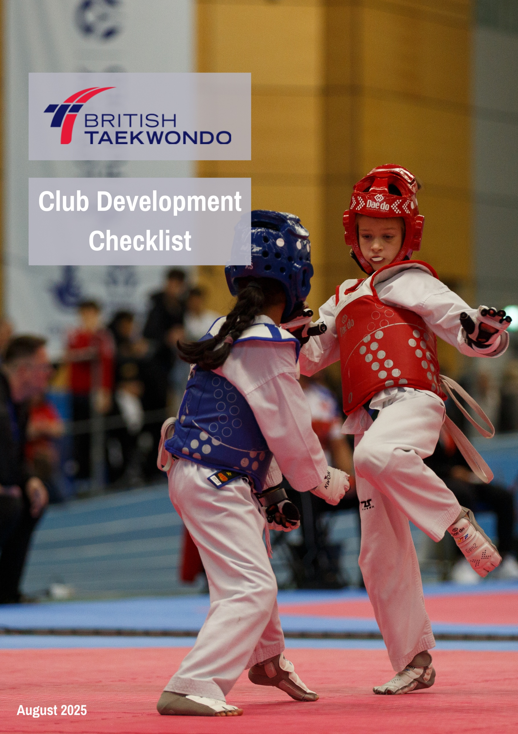
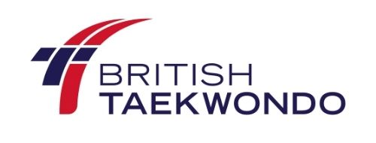
British Taekwondo Club Development Checklist
This Club Development Checklist is designed to help new and existing clubs assess their setup, ensure good governance, and build strong foundations for growth and sustainability.
Use this checklist to review key areas of your club’s development. It covers essential requirements for affiliation, good practice, and opportunities for further growth.
1. Club Governance
- Club has a clear constitution or governing document? ☐
- Club is affiliated with British Taekwondo ☐
- Key roles are in place (Chair, Secretary, Treasurer, Welfare Officer) ☐
- Club holds regular committee meetings and keeps minutes ☐
- Club has appropriate legal structure (e.g. unincorporated, CIO, company limited by guarantee) – for guidance click HERE ☐
- Trustees/committee members understand their legal and financial responsibilities ☐

2. Safeguarding & Welfare
- Appointed Welfare Officer with up-to-date training. For guidance, click HERE ☐
- All coaches and volunteers have enhanced DBS or PVG checks (completed through the My Club Hub) ☐
- Safeguarding policies are in place and accessible ☐
- Club follows British Taekwondo’s Safeguarding and Welfare Guidelines ☐

- Clear procedures for reporting concerns ☐

3. Coaching & Workforce
- All coaches are licensed by British Taekwondo, holding a valid DBS or PVG ☐
- Coaches hold up-to-date qualifications (Level 1, 2) ☐
- Coaches have valid first aid certification ☐
- Club promotes ongoing CPD (Continuing Professional Development) ☐
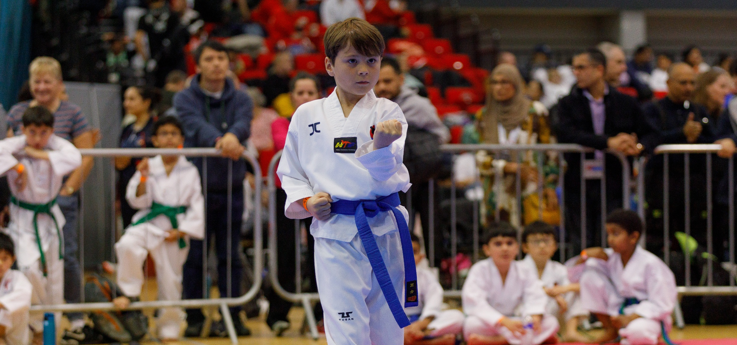
- Volunteers are supported and recognised ☐

4. Membership & Administration
- Club uses the British Taekwondo My Club Hub membership portal for registrations ☐
- Accurate and up-to-date membership records are kept ☐
- Clear system for collecting fees and managing finances ☐
- GDPR-compliant procedures for handling personal data ☐
- Club communicates regularly with members (email, social media, website) ☐

5. Insurance & Finance
- Club holds appropriate insurance cover via British Taekwondo ☐
- Transparent financial procedures (e.g., dual signatories, bank account) ☐
- Annual financial summary or report is produced ☐
- Exploring or using relevant funding opportunities or grants ☐

6. Inclusion & Equality
- Club has an Equality, Equity, Diversity & Inclusion (EEDI) statement or policy ☐
- Sessions are inclusive and accessible to different age groups and abilities ☐
- Opportunities for Para/Disability Taekwondo are considered ☐
- Club environment promotes respect, inclusion, and community values ☐

7. Development & Growth
- Club has a vision or development plan for the next 1–3 years ☐
- Engages with local schools, councils, or community organisations ☐
- Promotes junior leadership pathways or youth development ☐
- Hosts or attends British Taekwondo events, gradings, or competitions ☐
- Seeks feedback from members to improve sessions and services ☐

Next Steps
- Review any unchecked areas and prioritise actions for improvement
- Reach out to the British Taekwondo Development Team for support or resources
- Consider applying for quality assurance standards in sport
- Use this checklist annually to measure progress and maintain standards

